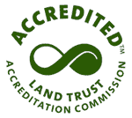
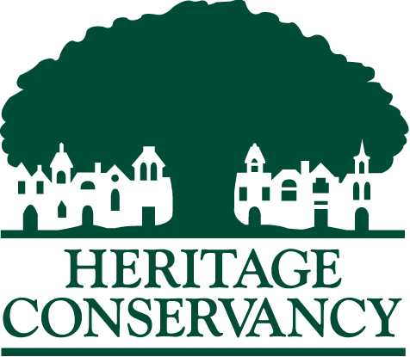

To preserve and protect our natural and historic heritage

Job Title: Conservation Steward Intern (Paid $14.00/hr; Summer 2025; Up to 4 positions available)

Purpose of Position: To assist Heritage Conservancy with maintenance and management of our preserved properties throughout Bucks County and gain experience at a nationally accredited land trust.

Work Location: Heritage Conservancy at 85 Old Dublin Pike, Doylestown, PA 18901 and various properties throughout Bucks County.

Benefits to Intern: The opportunity to gain a thorough knowledge of Heritage Conservancy’s preserved properties and the maintenance required to properly care for these important natural areas that make Bucks County so unique and beautiful. Learn about the workings of a nationally accredited land trust and gain hands-on experience in conservation stewardship.

Required Skills & Knowledge:
- Position advantageous to students majoring in: Environmental Resource Management, Environmental Sciences, Biology, Conservation Biology, Ecology or other related science major, Wildlife and Fisheries Management. Other majors will be considered.
- Detail oriented, ability to take direction and complete tasks;
- Able to work both independently and cooperatively on a team with staff, interns, and volunteers;
- Must be self-motivated and eager to learn and work;
- Ability to endure potentially variable factors associated with outdoor work;
- Physically capable of hiking several miles, over uneven terrain, and carry 15- 35lbs. of equipment;
- Positive attitude, light-hearted nature and ability to work in a flexible work environment a plus;
- Reliable transportation is required.

Anticipated Activities: The Conservation Steward Intern may be trained in, but not limited to:
- Assist with forest monitoring and reforestation projects on various properties.
- Assist Heritage Conservancy staff with various management activities on properties throughout Bucks County such as habitat restoration, boundary monitoring, and mowing grass on trails and/or near property entries;
- Manage invasive plants using physical, mechanical, chemical and torch methods while preserving native plants;
- Occasionally interact with adjacent property owners and/or visitors to Heritage Conservancy owned properties;
- Survey the flora and fauna as needed on properties;
- Monitor and occasionally maintain various wildlife habitats both artificial (i.e. nest-boxes) and natural (i.e. vernal pools);
- Maintain and possibly construct trails for recreational enjoyment of community;
- Maintain necessary equipment for property management;

Expectations: The responsibilities of the Conservation Steward Intern are:
- Report completed activities and total work hours to Heritage Conservancy at the end of each week.
- Represent yourself in a professional and respectful manner throughout the internship as you are representing Heritage Conservancy.
- Comply with all Heritage Conservancy workplace safety rules and regulations that are in effect.

Outcomes/Goals: To further Heritage Conservancy’s mission by assisting with stewardship and management of our preserved properties. To provide the intern with experience in property maintenance at a nationally accredited land trust.

Training & Support Plan: Training and monitoring will be provided by Land Conservation Manager, Jim Drennan and Senior Conservation Biologist, Tyler Kovacs.

Time Commitment: Approximately 30 hours per week. Tentative weekly schedule will be Monday through Thursday 7:30 AM to 3:30 PM.

Length of Appointment: Between May 19 and August 7 (12 weeks, 11 weeks paid and one week of unpaid vacation). Continuation of internship is dependent upon satisfactory progress of work.

Minimum Age Requirement: 18

Dress Code: Appropriate clothes for field work such as long pants, t-shirts, and sturdy close-toed shoes like hiking boots. Dress appropriately for varied weather conditions, e.g. rain gear and boots.

Reports To: Jim Drennan, (267) 714-5342 or jdrennan@heritageconservancy.org

Heritage Conservancy seeks team members who represent the communities we serve, strives to foster an inclusive work environment, and is an Equal Employment Opportunity organization.

How to Apply: Submit cover letter and resume to Jim Drennan at jdrennan@heritageconservancy.org In your email, please include how you found out about this internship.
Accepting applications until 03/28/25.

